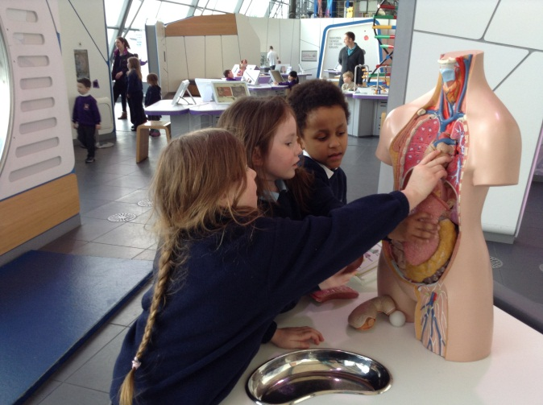
Best Trip Ever To Glasgow Science Centre
Rural school visits Glasgow for educational experience.
By Emma Bell and Lucy Powell

On Wednesday 28th of January Dalmally Primary School took a trip to Glasgow Science Centre and the Tall Ship on the River Clyde. The trip was made because of the educational value of having all hands on experience.
Miss O’Brian’s class, P1/2, were all excited about the body works exhibit. Anna from P2 said: “I enjoyed looking around and learning about the human body.”
The P3/4 class visited the planetarium because they were doing a topic on space. Their class teachers Miss MacKinnon felt that it was useful for the children to bring back information.
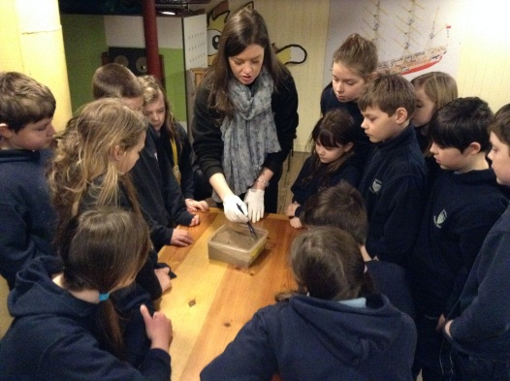

P5/6/7 visited the tall ship, which was docked on the River Clyde, as part of their Titanic topic. The children put their gloves on and picked up their brushes and became marine archaeologists for the day. Mrs Wright, classroom assistant, said: It was “a phenomenal experience.” Unfortunately they didn’t have a lot of time to explore but it has given them inspiration to discover as much as possible about this histoncal event.
Unusually the whole school made an educational trip in one day. The funds were raised by hosting a Holly tea supported by relatives of the pupils, staff and community members.

