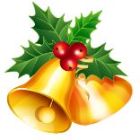
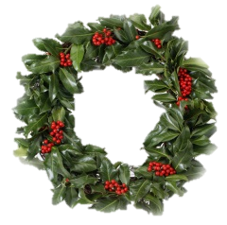
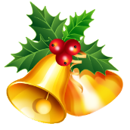
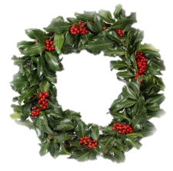
Holly-Tea
On Wednesday the 3rd of December Dalmally primary school had a Holly tea. There was a card, hanging ornaments and napkin ring stall. There was snowman, decorated glasses, pom-pom Santa’s and snowmen and pinecone skiers. There was a baking stall and guess the weight of the Christmas cake, guess the birthday of the toy dog and find the treasure on the treasure map and also a raffle. It was really fun. I was on the cards and hanging ornaments stall. I was there with Isla, Emma, me and Iona. I was helping Isla and Emma with taking people’s money and giving them their change. Iona was staying outside to help people chose different ornaments. The different things I made for the Holly-Tea were:
- Two different decorated glasses, one wine glass and one normal.
- One snowman with a pink hat and scarf
- A hanging star made out of paper and beads
- An glitter pinecone to hang on Christmas tree
- Cards: Christmas puddings, hanging bobble cards, star cards, snowman cards and Sleigh pulled by a reindeer.
We had to use lots of different skills to make the different things. We had to be patent and we had to be abe

